**Lab Exercise 5**

**Aim:** Installation of Maven and Eclipse plugin.

Install JDK and Maven 3.3.9 and set environment variable.

**Installation of JDK:**

* Download link of JDK 11 SE toolkit:  
    
  <https://www.oracle.com/technetwork/java/javase/downloads/jdk11-downloads-5066655.html>
* Setting the environment variables:  
    
  (A) JAVA_HOME: C:\Program Files\Java\jdk-11.0.1  
  (B) path: C:\Program Files\Java\jdk-11.0.1\bin
* Checking the configuration via the command line using the command:  
  java -version

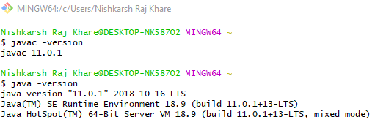

**Installation of Maven:**

* Download link for Maven 3.3.9:  
    
  <https://archive.apache.org/dist/maven/maven-3/3.3.9/>
* Setting up the environment variables:  
    
  M2_HOME: C:\Users\Nishkarsh Raj Khare\.m2
* Checking the configuration using **mvn -version** command.

